Attempt 2:

EPS:-2 Dim:-3 Min-pt 3

X=Time Y=Before Z=After

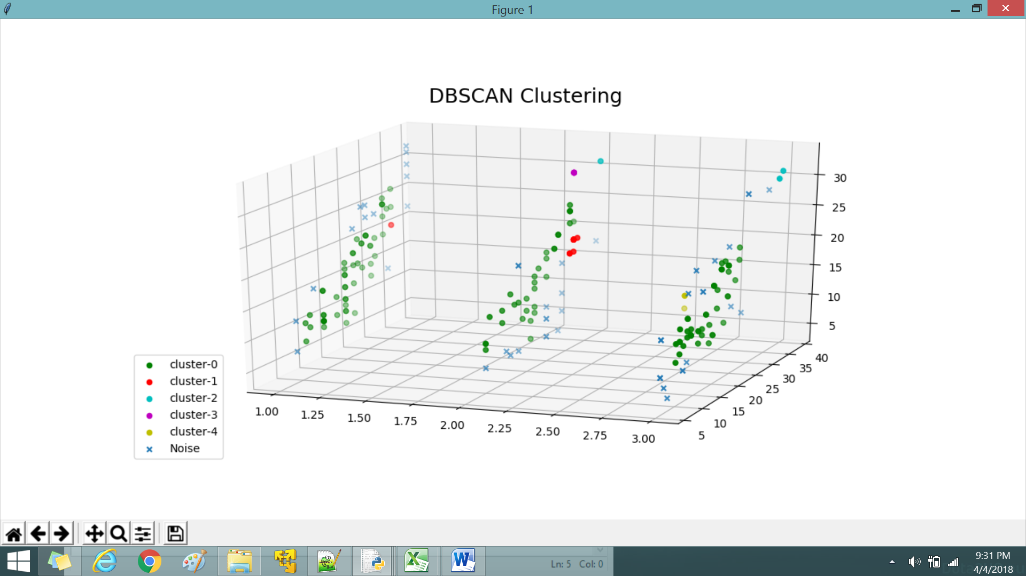

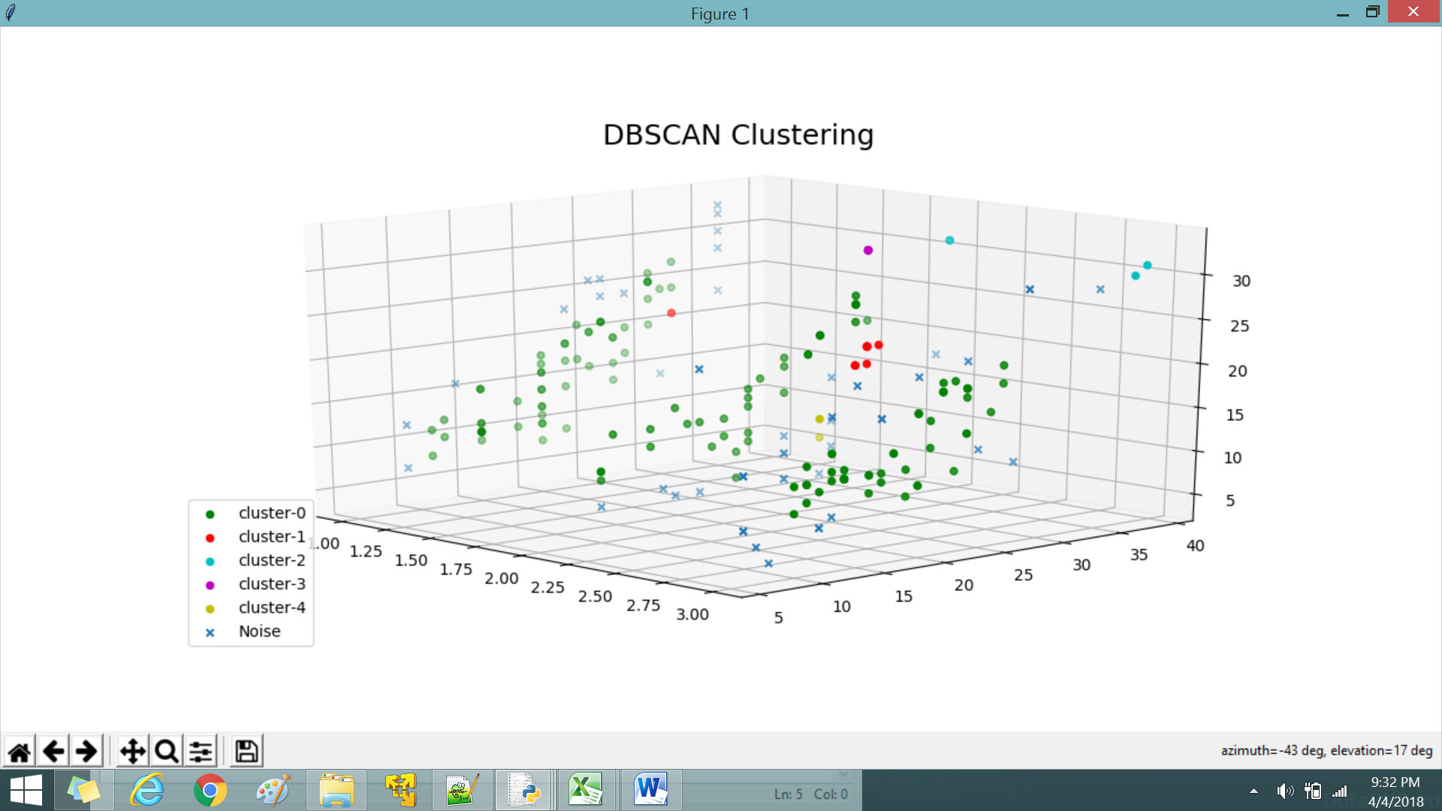

Attempt 3:

EPS:-3 Dim:-3 Min-pt 3

X=Time Y=Before Z=After

